Name:___________________________________ Date:______________________________
This exam contains 8 pages of questions and reference material; confirm your packet is complete. There are 31 questions (pages 1-6 pages) on this examination totaling 106 points (scored out of 100 points). You have 1.0 hr, 15 min to complete this examination and may only use a basic scientific calculator. All work must be shown for credit for Questions 21-31. An Equation Sheet and a scratch sheet will be provided to you. Clearly write your name of this scratch sheet and submit at the end of the examination period. If you need additional scratch paper, please raise your hand. Please sign the honor code below to have exam graded and keep your work covered at all times. If you need further clarification, please raise your hand. Good Luck! Honor Code: The work presented in this exam is my own. I did not given or receive any assistance.
Signature_________________________________________________________

For Questions 1 – 20, either circle the correct answer, fill-in the blanks or rank your answers. Each answer or blank is 1.5 points, unless otherwise stated.

- The amount of electrons flowing in a specific direction is termed the
  - electric current
  - electric resistance
  - voltage
  - dipole
  - None of these

- A collection of lines that map out the directions in which compass needle would point is called a(n)
  - compass field
  - electric field
  - magnetic dipole
  - magnetic field
  - None of these

- Coulomb's Law states that the force of static electricity between two objects is inversely proportional to
  - the amount of charge on the objects
  - the square of the distance between the objects
  - the size of the objects
  - the direction of the charge on the object

- The measure of the atomic kinetic energy contained in an object is referred to as its
  - entropy
  - thermal energy
  - heat transfer
  - wave energy
  - heat capacity

- The transfer of heat by bulk motion of gases or fluids is referred to as
  - convection
  - conduction
  - radiation
  - thermal movement

- _______________ True or False? The velocity of electromagnetic radiation (EMR) changes, depending on the type of radiation source.

- _______________ True or False? For EMR, wavelength and frequency are directly related.

- Which of the following EMR has the shortest wavelength?
  - am radio waves
  - fm radio waves
  - microwaves
  - red light

- Which of the following EMR has the lowest energy?
  - am radio waves
  - fm radio waves
  - microwaves
  - red light

- Which of the following materials has the highest thermal conductivity?
  - wood
  - metal
  - air
  - fur

- Entropy states that all isolated systems spontaneously tend toward __________________________________.
- When water converts from liquid phase to solid phase, entropy _____________________________________. Choices: increases, decreases, remains the same.
- This type of EMR is used to destroy bacteria on produce (prevent spoilage) and destroy tumors/cancer_____________________________________________________________________________.
- This type of EMR is used to visualize internal body structures _______________________________________.
- The Sun transfers most of its heat energy to the earth by means of ___________________________ radiation.
- The "push" that the electron feels in a household circuit is called ____________________________________.
- Any material that inhibits the transfer of heat is called a(n) __________________________________ and an everyday example of this type of material is _____________________________________________________.
- Water freezes at ________________ ºC and _______________________ ºF.
- Water boils at ____________________K.
- Rank the following EMR in order of increasing wavelength, from short to long wavelengths (4 pts)
green light ultraviolet light Infrared microwaves indigo light

________________ < ________________ < ________________ < ________________ <________________
short wavelengths long wavelengths
- Briefly describe the mechanism (how) by which heat is transferred in a metal. Be specific, please. (5 pts)

- Water has a large "heat sink" compared to many objects. Explain what this means for water in terms of changing temperature when absorbing heat when compared to objects with a small "heat sink." (5 pts)

- Consider two positive charges very close to each other. Use an arrow(s) to show the direction of Coulomb's force between the two charges. (4 pts)

+
+

- Consider the two different charge systems below (a and b). Which has the greatest attractive Coulomb force: (a) or (b)? (circle one). (5 pts)

a. Charges have 1 unit of separation between them.
+2
-1

b. Charges have 2 units of separation between them.
-1
+4

- A bar magnet is pushed up and down through a coiled wire with many loops. (4 pts, 2 pts each)
a. Is this an example of an electric generator or electric motor? Circle one.

b. What happens when the magnet (and coil) is stationary?

- Two bar magnets are placed close to each other and experience an attractive force. Provide the proper "poles" in each bar magnet. (5 pts)

- You are watching a recorded showing of one of the long (5 hr) World Series games for the Astros vs Dodgers.
a. How much current does your 100-watt TV use when plugged into a 115 V circuit in your home. (4 pts)

b. What is the resistance in the circuit? (4 pts)

- Consider the numbered electromagnetic waves in the diagram below. Answer each question below. (7.5 pts total, 2.5 pts each.)
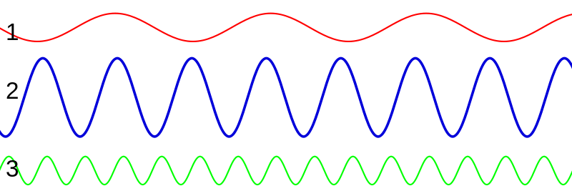

Question | Correct wave NUMBER from diagram above
Which EMR has the lowest energy?
Which EMR has the shortest wavelength?
Which EMR has the highest frequency?

29. What is the wavelength (in meters) of San Diego's KSON Country Station, with a call sign of 97.3 MHz? (6 pts)

30. A glass of water at 60.0 ^{O}F sits near a kitchen stove. A heated spoon at 80.5 ^{O}F is placed into the glass of water, after the cook samples the pasta sauce that is being cooked.
a. The initial temperature of the spoon in Celsius is _____________________ ºC (work must be shown below for credit). (5 pts)

b. Heat will transfer from the _______________________ to the _______________________. (4 pts total)
c. The final temperature of the water will be below___________________________ ^{O}F. (2 pts)
31. Which is more efficient (ENERGY-wise), to use in your home, with 110 V outlets: a 10 amp air conditioner for one hour to completely cool your room or a 3-amp electric fan to keep a constant flow of air over your body for five hours? Hint: You will need to use two separate equations for each object and ultimately solve for energy used! Show your work for credit. (10 pts)

RESOURCE SHEET

KE = 1/2 mv²

^{O}F = (1.8 x ºC) + 32

K = ºC + 273

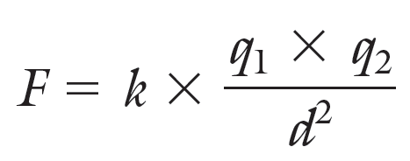

1 Coulomb = 6.3 x 10¹⁸ electrons

k = 9 x 10⁹ $\frac{N⋅m^{2}}{C^{2}}$

V = i R

P = i V

P = $\frac{\text{energy}}{\text{time}}$

Frequency = 1 Hertz (Hz) = 1 cycle
1 sec

Wave velocity = wavelength (m) x frequency (Hz)

Wavelength (m) = velocity ($\frac{m}{s}$)
frequency ($\frac{1}{s}$)

c = wavelength (m) x frequency ($\frac{1}{s}$)

c = 3.0 x 10⁸ $\frac{m}{s}$ or 300,000 $\frac{\text{km}}{s}$

Scratch Paper NAME:__________________________________

